**Aim:**

To create and configure a suitable network topology for both LAN and WAN using Cisco Packet Tracer, involving 10-15 computers, switches, and routers. The goal is to simulate the transmission of a message from computer in one network to a computer in another network, ensuring proper connectivity and communication across different network segments.

**Procedure:**

**1. Topology Design:**

LAN Configuration:

1. Design a network topology with at least 10 computers connected to switches. Ensure the LAN segment appropriate switch connectivity.

2. Implement WAN Configuration to connect the LAN network to another network using routers. This involves creating a broader network structure to facilitate communication between distinct LANs.

**2. Network Setup in Cisco Packet Tracer:**

Add Devices:

1. Place and connect 10-15 computers within the LAN segment.

2. Add at least 2 switches to facilitate the connection of the computers. 3. Introduce at least 2 routers to establish WAN connectivity.

Configure IP Addresses:

1. Assign IP addresses to all computers within the LAN segment, ensuring each computer has a unique address within the same subnet.

2. Configure router interfaces with appropriate IP addresses that enable routing between the LAN and WAN segments.

3. Set up routing protocols or static routes as required to ensure seamless communication between different LANs through the WAN.

**4. Configuration Steps:**

LAN Configuration:

1. Connect computers to the switches using network cables.

2. Configure IP addresses on each computer, ensuring that each address is unique and within the same subnet.

3. Connect the switches to each other to ensure network expansion and device communication within the LAN.

WAN Configuration:

1. Connect the routers to each other to establish the WAN connection.

2. Configure the router interfaces with IP addresses that facilitate communication across the WAN.

3. Set up routing, either static or dynamic, to ensure that the routers can route traffic between different LAN segments.

**4. Simulation:**

Send a Message:

1. Use Cisco Packet Tracer's simulation mode to monitor and test network activity.

2. Configure and send a message from a computer in one network (e.g., LAN1) to a computer in another network (e.g., LAN2).

3. Capture and verify the message transmission to ensure that the message is successfully delivered from o network to the other.

**Result:**

Network Topology and Configuration:

* LAN Setup:
* Computers: 12 computers were successfully placed and connected.
* Switches: 2 switches were used to manage the LAN connections.
* IP Configuration: IP addresses were assigned to all computers, ensuring they were within the same subnet.
* WAN Setup:
* Routers: 2 routers were configured to connect two distinct LANs.
* Router IP Configuration: Routers were assigned IP addresses on their interfaces to connect the LANsand to each other.

Routing Protocols: Static routes were implemented to ensure traffic could flow between the LAN segments.

Message Transmission:

* A message was successfully sent from a computer in LAN1 to a computer in LAN2.
* The simulation mode in Cisco Packet Tracer confirmed that the message was routed correctly through the WAN and received at the destination computer.

The network topology, IP configuration, routing setup, and message transmission were all verified to be functioning as expected, demonstrating successful inter-network communication.

**Screenshots:**

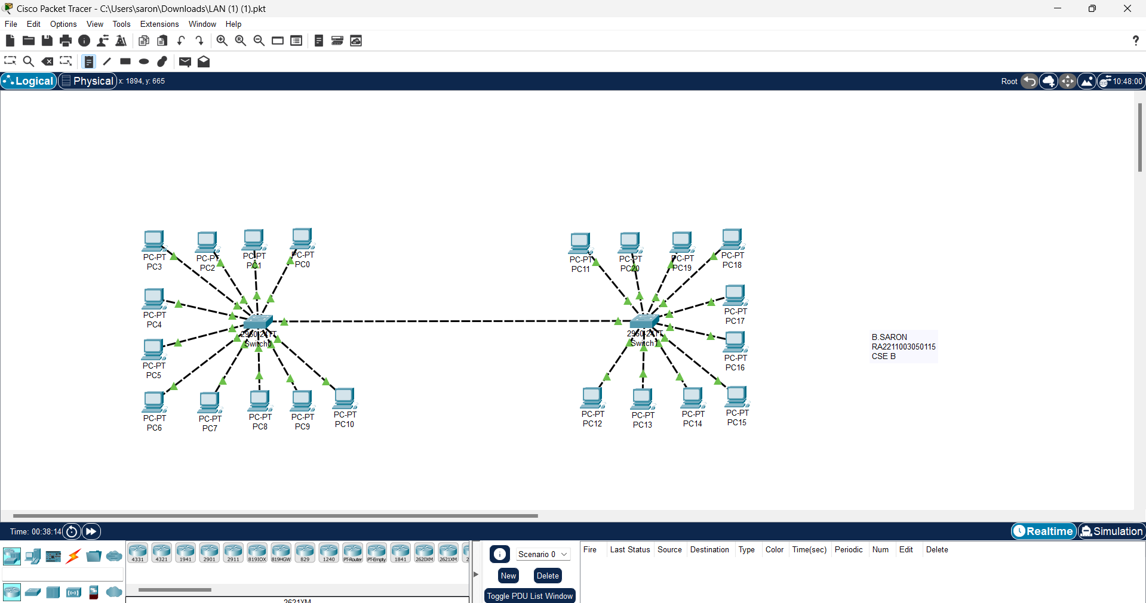LAN:

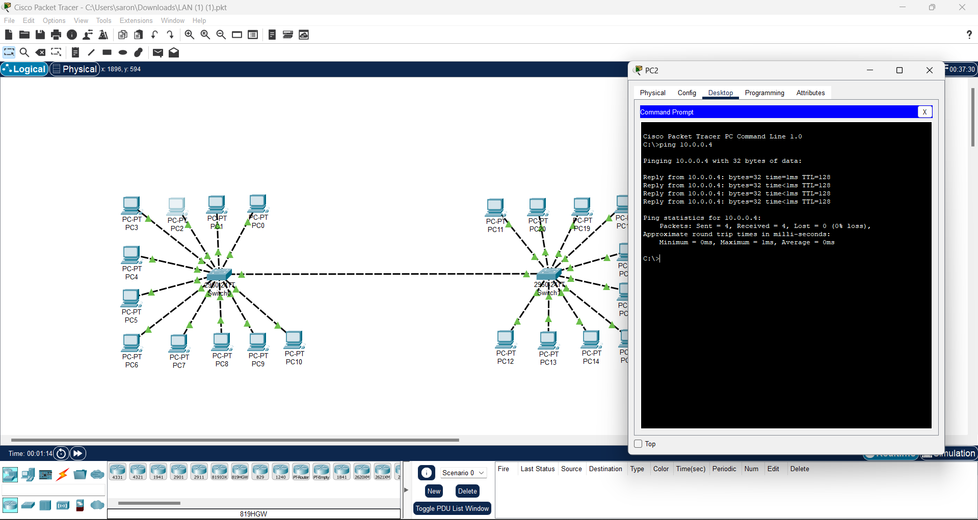

WAN:

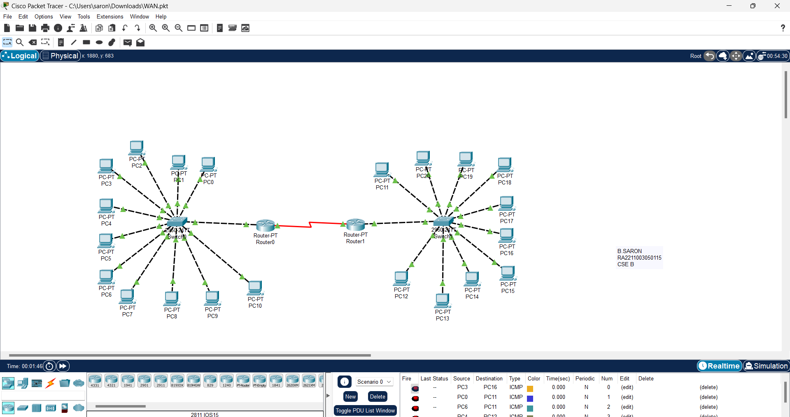

Name: B.Saron

Class: CSE-B

Reg no: RA2211003050115